Exercise 1: Setting Up Junit
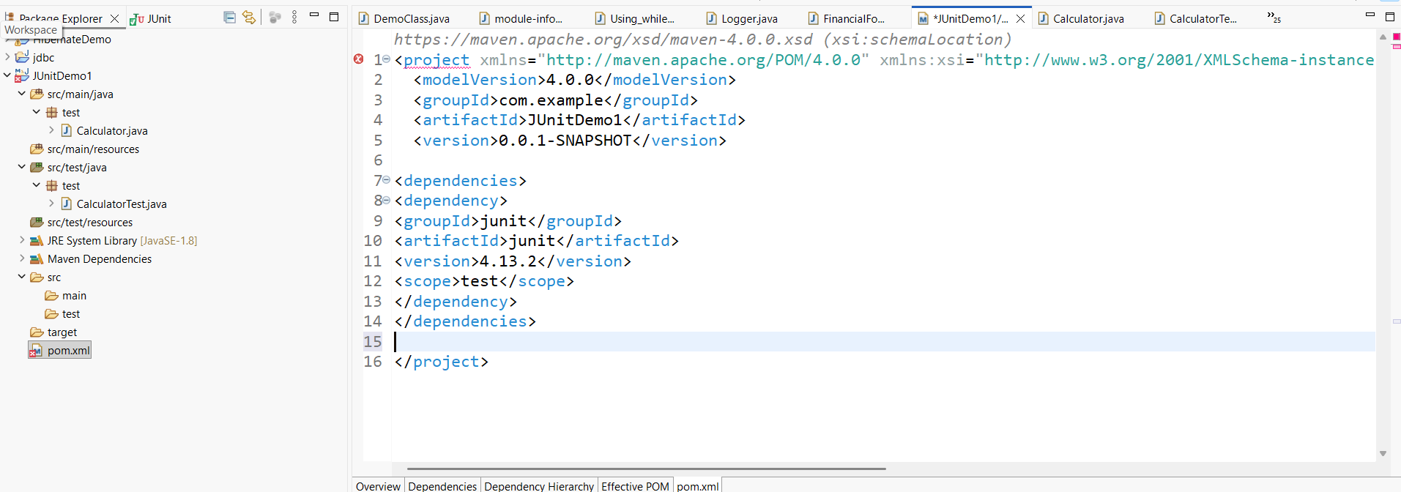<dependencies>
<dependency>
<groupId>junit</groupId>
<artifactId>junit</artifactId>
<version>4.13.2</version>
<scope>test</scope>
</dependency>
</dependencies>

Calculator.java
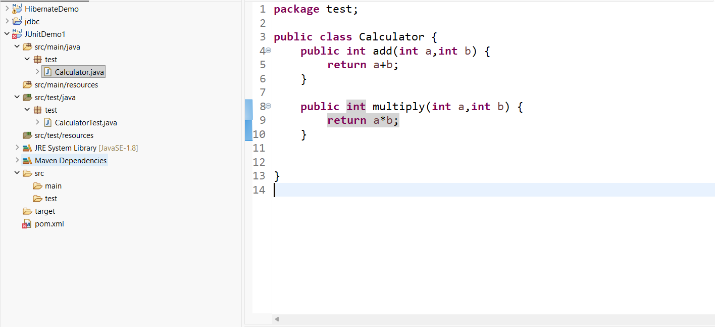

Test class creation

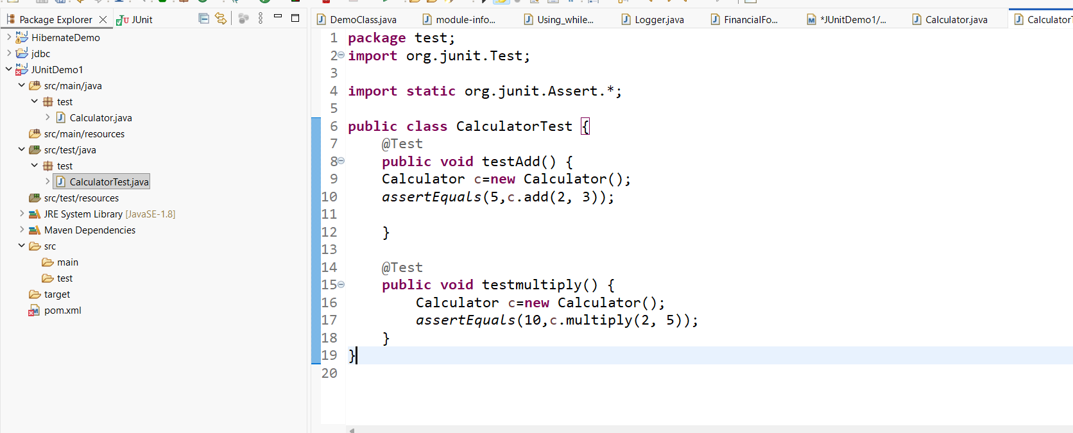
Ouput:
